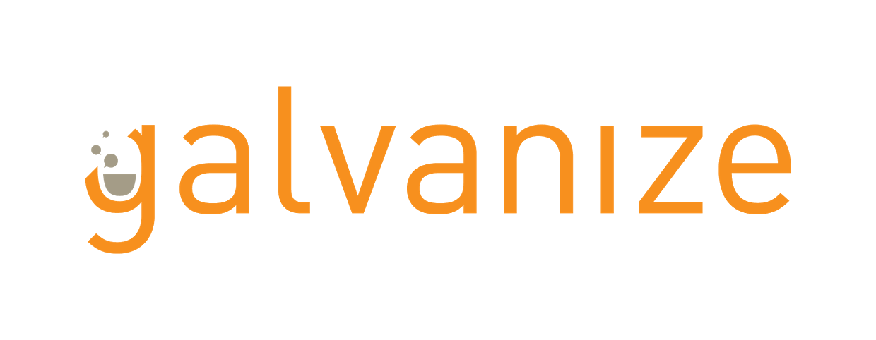

# Project Title

## Summary:

*Answer the following questions in a few sentences:*What is this project about?

What new tech did you learn?   
What are ~3 key features of this project?   
What challenges did you encounter?  
Anything else the reader should know?

## 

## 

## Tech used:

**Front End   
•   
•**

**•**

**Back End   
•   
•   
•**

## 

## Project links:

[Link github repos and demos here]